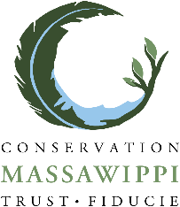
Legal name of your business :
Name of the owner(s) :
Is your business conventional or certified organic?

If your company is certified organic, by which organisation was it certified?
Mailing Address :
Home Telephone:
Cellular Telephone :
Email :
Introduce us to your farm!

What are the main products of your business?
☐Agriculture | ☐ Maple Syrup | ☐ Potatoes
☐ Beef Cattle | ☐ Fruit Tress | ☐ Greenhouse crops
☐ Dairy Cattle | ☐ Arable crops | ☐ Viticulture
☐ Goat production | ☐ Vegetable growing | ☐ Other (specify) :
☐ Equine production | ☐ Ornamental Horticulture
☐ Sheep production | ☐ Small fruits
☐ Pig Production | ☐ Fodder Plants

What acreage do you farm?
Area (ha):
Crop (ha):

What is your livestock?
Animal Categories | Inventory (heads)

- How would you describe your farm?

- Describe your company's history and leadership in the use of best agri-environmental practices at the regional level. (maximum 3000 characters)

- Describe your agri-environmental management practices for fertilizer and waste materials on the farm. (3000 characters maximum)

- Describe how you improve the health and conservation of your soils? (3000 characters maximum)

- Describe how you contribute to maintaining biodiversity on your farmland. (3000 characters maximum)

- OPTIONAL Are there any other aspects of your farm's agri-environmental management that you would like us to know about? (3000 characters maximum)
END

Signed __________________________________ Dated _______________
Return to Massawippi Foundation P.O. Box 2582 North Hatley, Quebec, J0B 2C0
For any questions please email : foundationmassawippi@gmail.com

